**Quick guide for ODL controller webapp:**

User can login to the webapp by launching <http://172.29.145.37:8080/ODLController> . By providing the credentials and controller details proceed with your login.

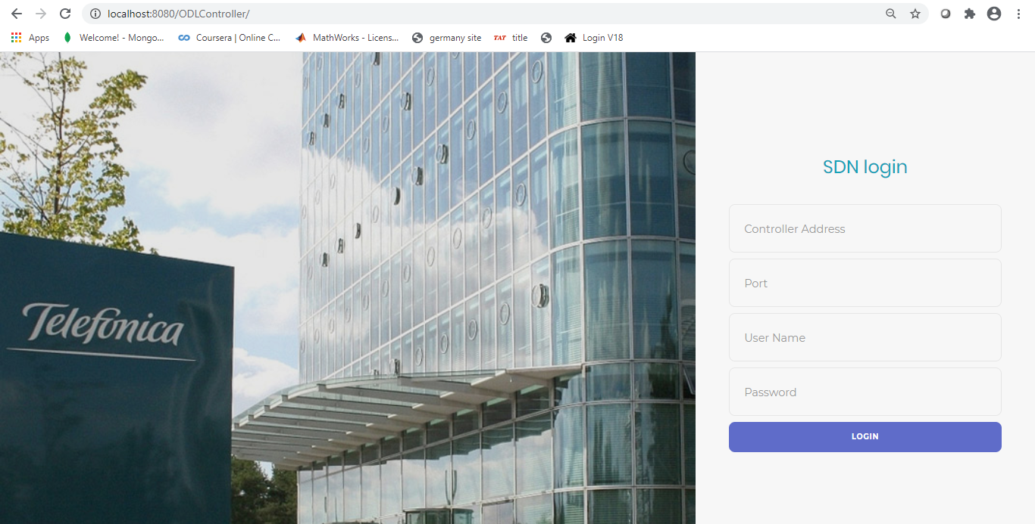

**Device Status:**

Click the controller 🡪 “Device status” option to view the current connection status of the mounted devices.

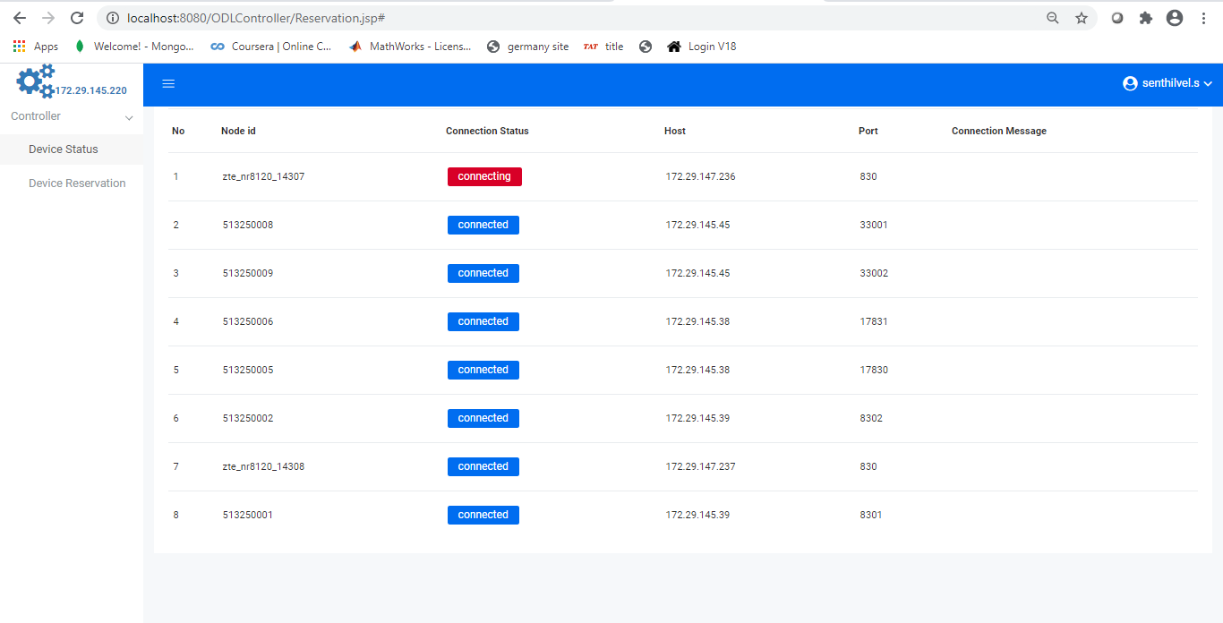

**Device Reservation:**

Mounted devices can be reserved for testing using the Device reservation page.

**View:**

By clicking controller 🡪 ‘Device reservation’ page will direct you to a table where you can view the reservation details.

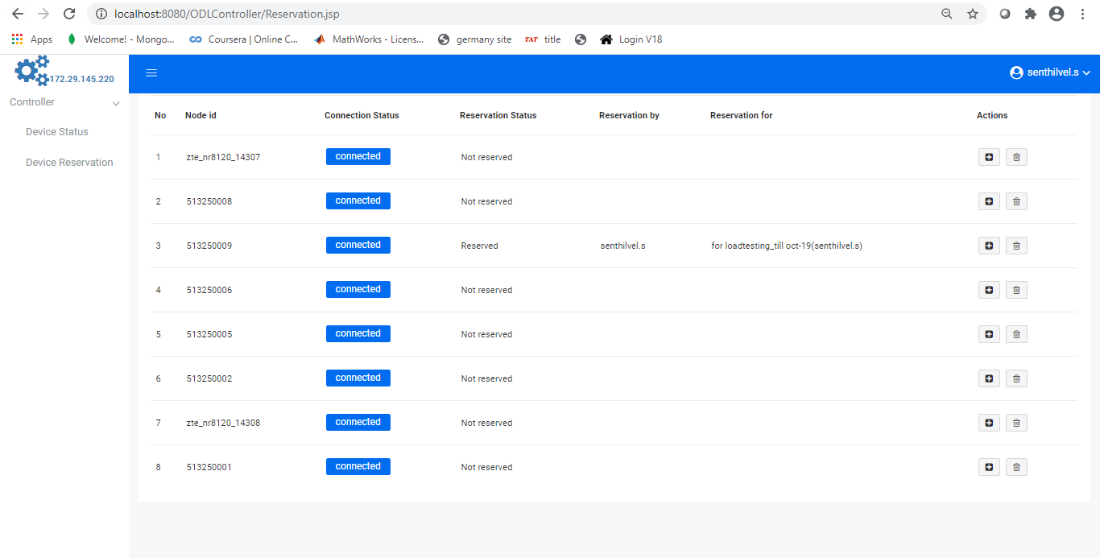

**Reservation:**

Click the button from the action column to open the reservation form. Fill the reason (with date if possible) and reserve the node.

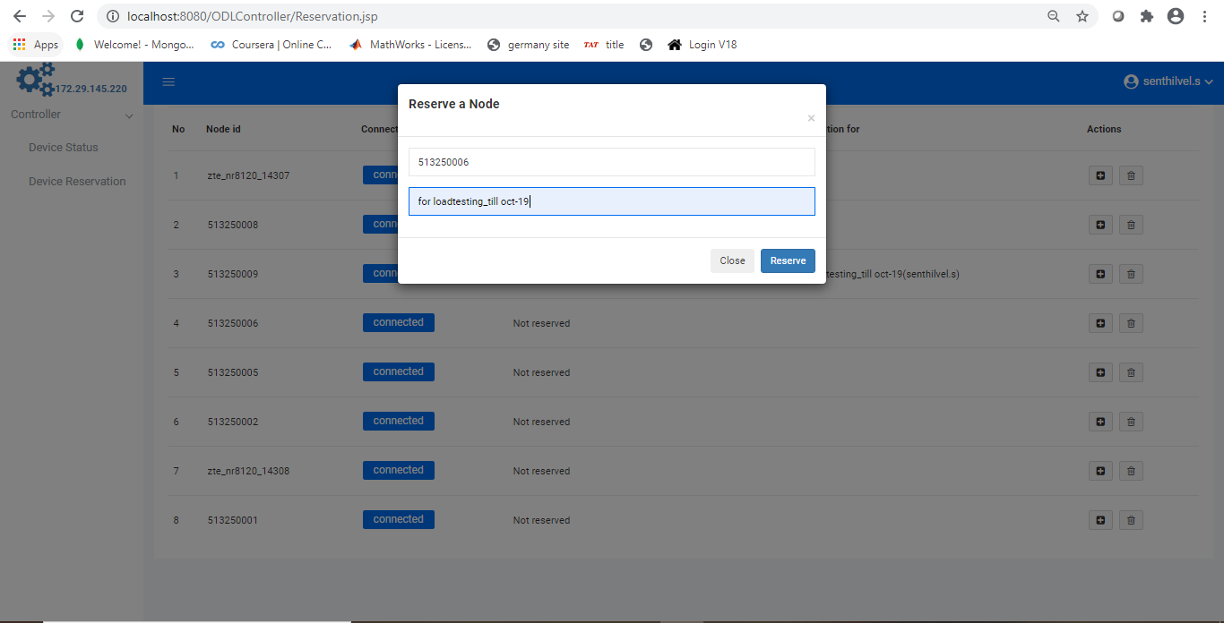

**Unreserve:**

Click the button from the action column to unreserve a node. Confirm the same and unreserve.

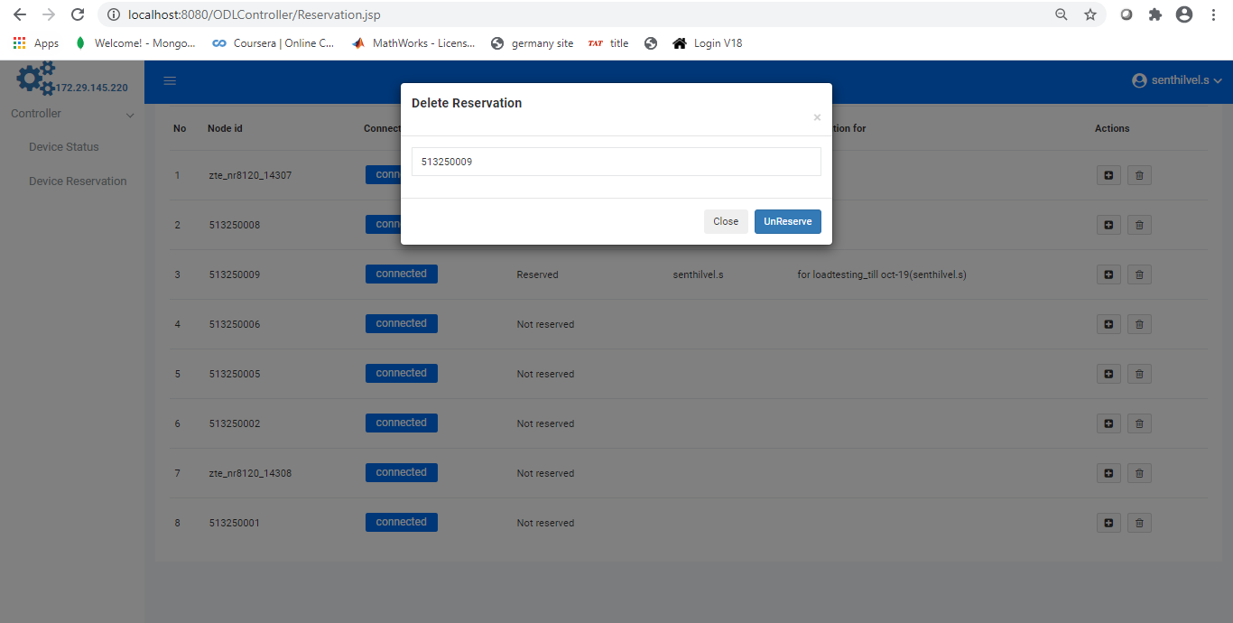

**Logout:**

Click on the logout option available in the dropdown next to the username to signout.

